

INFORMATION TECHNOLOGY PROGRAMME

COMP902 Advanced Information Technology Specialised Project
AI-Assisted Construction Workplace Management System
Final Report
Trimester 2, 2026

Student Name | Viacheslav Vorozhbit
Student ID | 20230119
Project Title
Supervisor | Dr. Saranya Selvarangan
Report# | 2
Date | 10 August 2026

Abstract
This work was completed as part of the COMP902 Specialized Project on AI-Assisted Construction Workplace Management System. The purpose of this study is to examine existing methods, approaches, and AI-based tools that are currently or could be used to assist small business managers in construction. Also, during the research process it plans to identify gaps that may exist in this area of business. The basis is a small existing construction company, the manager of which is faced with a daily routine in the form of similar repetitive tasks that can be automated.
The construction industry is a vital and rapidly growing sector of the economy. Conditions, legislation, standards, materials, tools, mechanisms, and work methods are constantly changing. However, maintaining high standards is essential to remain effective in this highly competitive market.
Why was a small organization chosen? Because large corporations have various departments responsible for different areas, and they have specialized software for each area. In a small business, all tasks fall to one or two managers, who must draft contracts, submit quotes, find contractors and suppliers, monitor the process and quality of works. This is a very labor-intensive process, especially when closing the reporting period, and requires the preparation of a large amount of documentation and reporting.
The use of AI technologies can help solve such problems. There are numerous similar AI tools on the market, and their number and capabilities are growing every year. The purpose of this research is to examine the most popular and suitable AI tools for use as construction manager assistants, as well as to identify potential existing gaps in this area.

Acknowledgment
In conducting my research, I would first and foremost like to express my gratitude to my instructor, Dr. Saranya Selvarangan, for her help and support throughout the project. She was always available, monitored the process, and provided helpful advice throughout the research. Thanks to her accumulated experience, she supervised the project quickly and concisely.
During the research process, I turned to many open sources of information that could help to understand this issue. These included literature, book publications, and YouTube videos. I found the YouTube content especially useful, where authors shared their knowledge and conveyed useful information in a concise and succinct manner, which is very helpful given the multitude of different sources. I'm also grateful to my supervisor, who gave me good advice and helped me fine-tune the structure of the project and reports.
I found Kevin Stratvert's video content very helpful. He introduced me to process management on Microsoft Power Automatic. He describes well and thoroughly, starting from the basics of the structure, its features, how to properly design the process, and which modules can be connected. Kevin demonstrates the wide range of capabilities of the PA and the applications in which it can be applied. Kevin also does a good job of describing how AI Builder can be integrated into the workflow and how it can enhance the overall capabilities of Power Automate.
Another interesting coach is Anders Jensen. He describes process design and how to organize variables and subprocesses very thoroughly and comprehensively. From his lessons, I learned firsthand how to easily and simply build a process for processing Outlook emails, how to make the process read emails and download attachments, and how to organize the process's folder structure. He also shared some very useful tips for scraping information from websites and downloading files from them. Andres delivers information in a lively, accessible manner, without losing sight of the nuances and pitfalls. Andres also explained well the difference between Power Automatic Cloud and Desktop versions, in which cases it is possible to use one and in which the other, and also what to do if you need to combine these processes, for example, call a desktop process from a cloud process and switch to it to perform local tasks.
I also found a lot of useful information from bloggers Thomas Jenssen and Devin Knight of Pragmatic Works. These guys have prepared entire training guides and even test sites and resources for student practice.
I'd also like to highlight the work of Leila Gharani; I found her leadership and work very helpful. She has a deep understanding of all Microsoft products, including Power BI and MS Office, and provides the best ways to use them, including in PA processes.
I also found the authors Kaisar Kurmangaliyev and Darrel Wilson very interesting and helpful. They provide fresh and very comprehensive information on the new AI Claude product. They provide step-by-step recommendations on how to properly set up a working environment, how to use it, and, most importantly, they describe the capabilities of this new product. And the capabilities, as it turns out, are very extensive.
I am grateful to these and many other authors who shared their knowledge and experience, expanded my knowledge in this area, and helped save time and make my research process more efficient.

Contents

Abstract 2
Acknowledgment 3
Introduction 6
Literature Review 7
Project Objectives 10
Project Scope 12
Out of Scope 14
Methodology 15
Practical Implementation and Technology Investigation 18
Microsoft Power Automate 18
Microsoft Copilot 20
AI Builder 20
Claude AI 21
Results 24
Conclusion 25
References 27

Introduction
Construction is a vital sector of the global economy, including New Zealand's. Technologies and landscape designs change, old structures become obsolete, are demolished, and are replaced by new ones, using modern materials and new technologies. The urbanization of cities and industrial sectors is growing, and all this requires the involvement of new technologies, machines and equipment to meet high standards and requirements. Construction includes a wide range of works and skills, organization of foundations, construction of walls, roofs, interior decoration, sewerage, electrical wiring, access to roads, sidewalks and landscape design of local areas. Traditionally, such construction projects have been handled by large construction corporations, which have departments responsible for each area. They employ financiers, accountants, designers, estimators, foremen, and work units. Typically, they outsource smaller construction companies to specific tasks, such as roofing for one company and plumbing for another. Mainly this due to the complexity of the management system, work organization and control over the execution of work. Even with modern databases and powerful corporate information systems, large construction companies require significant employee involvement to ensure that the process and final results of completed work remain at a high level.
Small construction companies specialize in a small and usually related range of tasks. But even with a limited number of tasks, construction management is a labor-intensive and demanding process. To be effective and successful in this competitive market, it's essential to closely monitor revenues and expenses, as well as the quality of work, to meet standards and satisfy client demands.
There is a lot of software that can solve such problems, from Microsoft Office to specialized tools like MathCAD or accounting programs. In addition, cloud services offer a wide range of services for centralized storage and managed use of information resources. But managing these broad tools requires a manager with certain competencies and a certain degree of involvement.
New AI-based tools can come to the rescue, they can be organized as mini-assistants and can perform a number of tasks automatically with analysis. The current research is dedicated to sorting through the vast amount of information to determine what can be best used in this area.
This project involves research and practical use of the capabilities of Microsoft's AI Copilot, as well as the low-code programming tool Power Automate, and its integration with MS Office and AI Builder programs.
As well as an alternative tool for comparison, which will be based on the use of AI Claude, which is an advanced approach to automating tasks and is very suitable for everyday routines.

Literature Review
During my research, I came across a large amount of information regarding AI-based automation and management in construction.
These included academic papers, journal articles, technical literature, and also manuals from Microsoft and content on YouTube.
It's worth noting that Microsoft's documentation for Power Automatic and AI Builder is well-organized, up-to-date, and has many examples, making it a good learning tool. Microsoft Learning is a well-structured guide with examples, exercises, and navigation.
In his analysis of artificial intelligence's potential in construction management, Eber (2020) makes the case that as building projects become more complex, so does the demand for technology assistance. The author talks about how AI may help with coordination, information processing, and organisational duties in challenging construction contexts. Eber makes a crucial point when he says that AI shouldn't be seen as merely a substitute for human intelligence. According to the author, human skills like innovation and prioritisation are crucial components of management that AI cannot completely replace. Rather, AI should be explored as a way to significantly assist human decision-makers.
This viewpoint is very pertinent to the current project. A similar idea underpins the suggested usage of AI mini-assistants: managers and directors are still in charge of setting priorities, exercising judgement, communicating, and making critical business choices, while AI may handle routine information processing and administrative duties. This lends credence to the idea that AI should complement human managers rather than take their place.
As Korke et al. (2023) in their article, many construction companies have management problems related to their productivity. Since coordination between departments and employees is important, they respond that this process is not sufficiently automated today. Insufficient organization in procurement and financing can lead to delays, reduced quality of work, and loss of personnel and materials. This can ultimately lead to customer dissatisfaction and loss of competitiveness. The authors of the article point out that Artificial Intelligence has great potential and may not yet be sufficiently used in this context, but could be more.
Ivanova et al. (2023) looked at the application of AI at different stages of the construction lifecycle. Throughout their review, they discovered applications such 3D modelling, computer vision, robotics, construction planning, machine learning, building maintenance, and optimisation. The authors also emphasised how AI can help with work planning, automate repetitive construction management duties, assess massive amounts of data, and spot possible issues early on. They did point out that when it comes to implementing cutting-edge technologies, the construction sector is still very conservative. These results provide credence to the prospective applications of AI in process automation and workplace management. However, this research looks into the useful application of accessible AI and workflow automation tools to help with ordinary workplace management chores rather than concentrating on large-scale AI systems like robotics or computer vision.
In 2023, Zabala-Vargas et al. did a thorough investigation on the application of big data, data science, and artificial intelligence (AI) to project management in the architecture, engineering, and construction (AEC) industry. The authors examined how these technologies can improve construction project planning, monitoring, and control as well as assist with a variety of project management responsibilities. The analysis shows that there are advantages and disadvantages to the increasing amount of data generated during construction projects. In order to support decision-making, cost management, scheduling, risk management, resource allocation, quality control, and project performance monitoring, big data technologies, data science, and artificial intelligence (AI) may analyse data from a variety of sources.
The authors emphasise how AI-based techniques can assist project managers in finding patterns in massive datasets and delivering data that would be challenging to acquire thru conventional manual analysis. One significant discovery is that these technologies could improve the efficiency and data-drivenness of construction project management. The authors do point out a number of obstacles, tho, such as the difficulty of combining data from various sources, the availability and quality of data, the requirement for suitable technical expertise, and the comparatively sluggish adoption of cutting-edge technologies in the construction sector.
Because it shows how AI and data-driven technologies may enhance construction management both theoretically and in real-world project management operations, this study is especially pertinent to the current project. However, this research explores a more focused and approachable approach: the use of AI-assisted workflow automation and document processing to support normal workplace management tasks, whereas the systematic review focuses extensively on Big Data, Data Science, and AI applications. This offers a real-world illustration of how some of the ideas mentioned by Zabala-Vargas et al. (2023) can be applied with instruments that are sold commercially.
Adebayo et al. (2025) carried out a structured literature review in a different study that looked at the advancement of AI applications in building project management. Applications in project planning, scheduling, cost management, risk assessment, resource optimisation, safety, and decision-making were noted by the authors. According to their analysis, artificial intelligence is gradually shifting from experimental to more useful applications in building project management. The authors also draw attention to issues including data quality, organisational opposition to AI adoption, technical expertise, and interoperability with current systems. These results underline the necessity of looking into workable and affordable AI solutions that can be included into current construction processes.
In addition to academic literature, helpful online resources were considered during the investigation. YouTube was particularly useful for current information on rapidly developing automation and artificial intelligence capabilities. While academic articles provided the theoretical foundation and research perspective, practical video content often demonstrated how certain tools might be set up and utilised to real-world workflows. This was particularly relevant to Power Automate, AI Builder, and other recently developed AI-assisted technologies, where practical examples may shed light on their current capabilities and future applications.
Hayawi and Shahriar (2024) look at how AI assistants have evolved from conventional copilots, which mainly offer users advice and assistance, to more independent AI agents that can carry out tasks and collaborate with people. The authors talk about how AI agents might be able to handle job sequences, communicate with various technologies, and assist users in finishing tasks at work.
Reliability, security, privacy, human oversight, and the possibility of erroneous or unanticipated behaviours are just a few of the difficulties the authors point out as being related to this progress. They stress that greater autonomy does not mean that human intervention is no longer necessary, especially when AI systems are employed for crucial business tasks.
The idea of employing AI-assisted mini-helpers to carry out particular repetitive workplace activities is supported by this research, which makes it pertinent to the current project. Such assistants can handle regular tasks while keeping people in charge of crucial choices, as opposed to trying to replace managers. When integrating AI agents in a small construction company, Hayawi and Shahriar's constraints also promote the usage of human verification and careful consideration of data security.
Das Swain et al. (2025) investigated the idea of an LLM-based AI coworker designed to support employes during interactions at work. Their research demonstrates how a large language model might be positioned as a collaborative assistant that works alongside a human, rather than only acting as a stand-alone chatbot or information retrieval tool. Humans are ultimately in command of decisions and actions, even tho AI can provide contextual support and advice.
Cattermole (2026) investigates the use of AI chatbots in the workplace, focusing on different sorts of colleague help and how well they correspond with employes' job requirements. The study emphasises the need of viewing AI not only as a technology tool, but also as a sort of workplace assistance that may help employes with a variety of activities.
This study is significant to the current project because it supports the concept that AI help should be tailored to the individual needs of a task. Rather than deploying a single general-purpose AI system for all tasks, different AI assistants could be built or chosen based on the sort of assistance necessary. This lends credence to the idea of specialist AI mini-assistants that can help managers with specific repetitive tasks within a small construction company.
Savaş (2025) presents a comprehensive review of the expanding role of artificial intelligence (AI) in construction project management, identifying numerous areas where AI technologies might help with project planning, monitoring, and decision-making. The study focuses on applications such as project scheduling, cost prediction, risk management, quality assurance, resource optimisation, safety management, and design management. These applications show that AI has the potential to solve some of the major problems connected with the complexity and uncertainty of construction projects. AI can help construction companies handle enormous amounts of project data, detect patterns, foresee future difficulties, and help managers make better decisions. Savaş's (2025) presentation emphasises that the significance of AI in building extends beyond advanced predictive technologies. Routine management activities can also be made more efficient thru automation and intelligent decision support technologies. By lowering the amount of manual labour necessary for repetitive tasks, such technologies enable project managers to devote more time to activities requiring human judgement and professional experience. This is especially crucial for construction companies, as administrative processes may still rely heavily on manual data entry, document processing, communication, and monitoring. However, Savaş (2025) emphasises that technical expertise alone does not guarantee successful AI adoption. Several barriers can stymie implementation, including limited access to high-quality data, a lack of digital skills, implementation costs, organisational reluctance, and difficulties integrating new technology with existing systems. These limits are particularly important for smaller construction companies, which may have fewer financial and human resources to enable large-scale digital transformation.
Savaş's (2025) findings emphasise the necessity for practical and accessible ways to AI adoption in construction management. Rather than requiring sophisticated and expensive AI systems, smaller businesses may benefit from beginning with targeted automation of well-defined business activities. Low-code technologies, such as Microsoft Power Automate, offer one viable solution, allowing businesses to automate repetitive administrative procedures while retaining human decision-making. This approach is especially pertinent to the current study, which looks into how AI-assisted automation might be used to improve workplace and project management procedures in a small construction company.
However, rather than serving as a replacement for peer-reviewed academic publications, YouTube information was recognised as an extra source. Academic articles established the theoretical foundations of the study, while a collection of professional and educational videos provided the practical application and modern features of the technologies under investigation.
Existing research shows that AI plays an increasingly important role in construction management, as well as the rising concept of AI as a coworker. However, there has been little practical research into how accessible AI and low-code automation technologies might be combined to create specialist AI assistants for small construction enterprises with limited human and technical resources.

Project Objectives
This project's primary goal was to find out how workflow automation and artificial intelligence might help with construction workplace management.
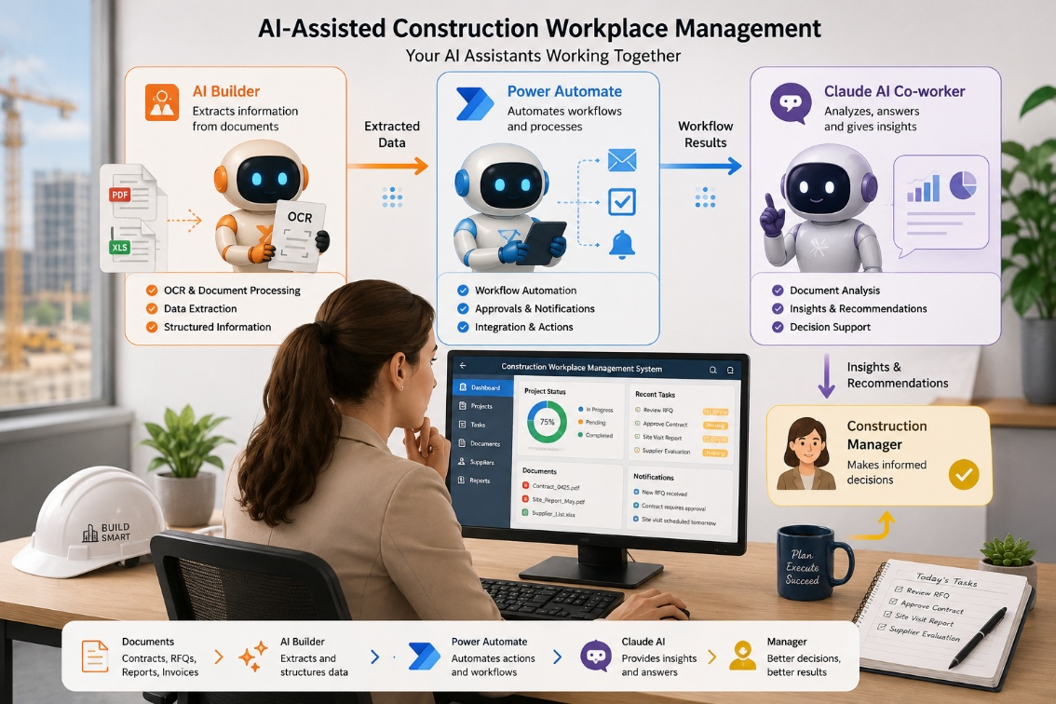
Instead than creating a novel artificial intelligence model, the initiative concentrated on real-world applications of AI. The project's particular goals were:
1. To look at AI's potential in construction management and pinpoint places where it could help with daily tasks.
2. To investigate how workflow automation can be used to improve information processing efficiency and decrease tedious manual chores.
3. To look at AI-based document processing, such as the conversion of information from documents into structured data using OCR and information extraction.
4. To use commercially available tools, especially Microsoft Power Automate and AI Builder, to implement and test useful AI-assisted workflows.
5. To assess the established solution's limitations and efficacy, including problems with accuracy, dependability, human verification, and workflow integration.
6. To evaluate the usefulness of AI-assisted automation for construction workplace management and pinpoint areas where the solution could be improved thru more research.

Project Scope
The scope of this study is to find out how workflow automation and artificial intelligence may help a small construction company with one or two managers with its day-to-day operations. The project focuses on this kind of organization since small businesses frequently lack the human resources to depend on the comprehensive enterprise systems, specialised IT teams, and technical support that are typically found in larger enterprises. Because of this, managers and directors in small organisations can have to spend a lot of time handling tedious administrative and information processing duties.
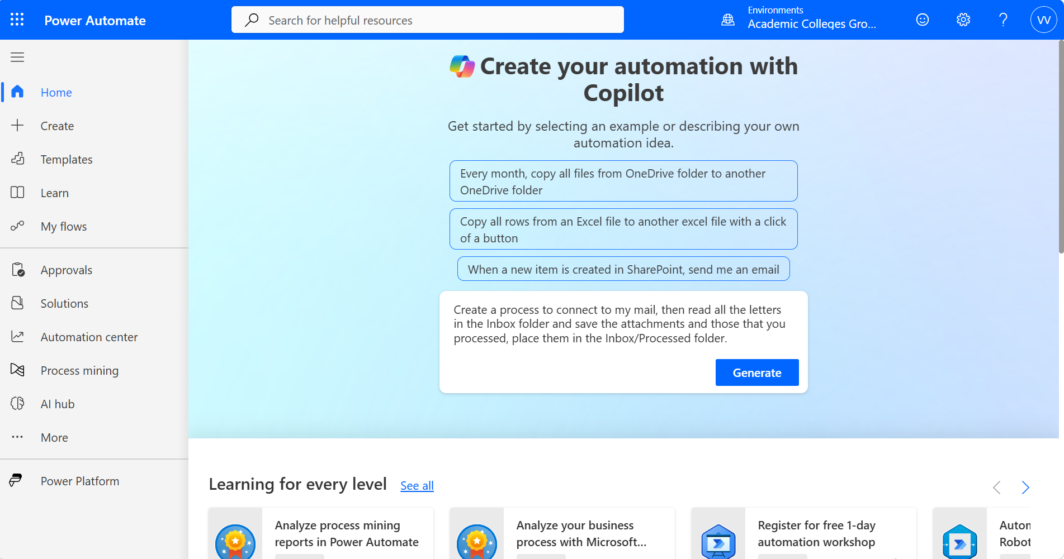
The project looks into the application of easily accessible automation and AI technologies, such as Claude, AI Builder, and Microsoft Power Automate. These technologies serve distinct purposes and are meant to enhance rather than replace one another. The fundamental framework for developing and linking automated processes is provided by Power Automate, a low-code workflow automation platform. By incorporating AI capabilities into these workflows, AI Builder enables processes to identify, extract, categorise, and analyse data from documents and other sources. As a general-purpose AI assistant, Claude offers more sophisticated skills for information analysis, reasoning, content creation, and helping with tasks that call for a greater level of comprehension. When these features are combined, automation can go beyond straightforward rule-based processes and offer a more adaptable AI-assisted method.
The idea of AI-assisted mini-helpers created to carry out particular repetitive activities is a key component of the project. The project investigates the idea of building several smaller assistants, each of which is in charge of a certain kind of task, as opposed to producing a single, massive, and sophisticated AI system. For instance, one assistant might keep an eye on and handle incoming emails and attachments, another would help organise or analyse data, and still another might extract information from documents. When needed, these assistants can collaborate with automated workflows and give the management information or finished tasks.
These mini-assistants are meant to handle repetitive and routine tasks that don't require constant human decision-making, not to assume the position of managers or directors. Managers and directors can devote more time to duties requiring human judgement, communication, planning, problem-solving, and business decision-making by assigning such jobs to automated and AI-assisted processes.
Using actual construction workplace settings, the project entails the design, implementation, and testing of certain AI-assisted processes. The practicality, utility, accuracy, dependability, and potential to minimise manual labour of the implemented solutions are assessed. The project also takes into account how human users and automated processes interact, including circumstances in which human verification is still required.
The project does not aim to replace current business systems or create a full enterprise construction management platform. Rather, it looks into whether a small business may gain significant advantages by integrating AI-based document processing, accessible cloud automation, and specialised AI assistants. The results are meant to illustrate a workable strategy that small construction companies may use without needing the kind of infrastructure and expert assistance typically found in major corporate settings.
This project's scope encompasses the following areas:
- Examining how AI can assist regular administrative and information-processing tasks in a small construction company is the focus of this investigation into AI in construction workplace management.
- Workflow automation with Microsoft Power Automate: looking into and putting into practice low-code processes for tasks like handling files, emails, attachments, and documents.
- AI-based document processing with AI Builder: exploring how AI may be used to identify, extract, and organise data from documents.
- General-purpose AI support based on Claude: An exploration of how an AI assistant can assist in tasks that require a higher degree of interpretation, such as information processing, analysis, and the preparation of summarised content.
- Creation of specialised AI mini-assistants—looking into how distinct AI-assisted procedures can be created to manage particular repetitive activities and cooperate with automated workflows.
- Evaluation of the combined approach: determining whether these technologies are appropriate for a small construction company with one or two managers, as well as their practical advantages, limitations, dependability, and data security considerations.

Out of Scope
The following topics are not included in this project's scope:
- The creation of a novel machine learning or artificial intelligence model. Instead than training a new model, the project makes use of already-available commercial AI tools.
- The replacement of current company software or the creation of a comprehensive enterprise-level construction management system.
- Automating intricate construction tasks that call for direct control of construction machinery, robotics, drones, or physical equipment.
- Complete automation of management choices. The project's goal is to support managers, not to take the place of their professional judgement and accountability.
- Putting the suggested approach into practice across several businesses or a sizable construction organization. The practical requirements of a small construction company with one or two managers are the project's primary focus.
- Creation of a commercial software application that is ready for production. The AI-assisted mini-helpers and implemented workflows are regarded as a working prototype for study and assessment.
- Total integration with all of a company's current accounting software, construction management software, business systems, and external services.
- Removal of human intervention from all automated procedures. Human review and approval may still be necessary for tasks involving critical choices, private data, or ambiguous AI outcomes.
- Thorough financial evaluation of a whole commercial implementation. The initiative does not offer a comprehensive business investment or return-on-investment analysis, but it does take prospective advantages and practical accessibility into account.

Methodology
A practical, applied research approach served as the foundation for this project's technique. In addition to examining the theoretical possibilities of AI in construction management, the goal was to determine how existing automation and AI technologies might be used for real-world jobs in a small construction company.
Rank | Platform | Approx. Value
1 | ChatGPT | 52–54% (down from ~76–79% a year earlier)
2 | Gemini | 27–28% (up sharply from ~6–9% YoY)
3 | Claude | 9–12% (strong growth, sometimes tripling earlier shares)
4 | DeepSeek | ~3.5–4%
5 | Grok | ~2.3–2.8%
6–7 | Copilot / Perplexity | ~1–2% each
Statistics of using the most popular AI for general tasks
A survey of the literature on artificial intelligence in construction management, workflow automation, Big Data, document processing, and AI-assisted project management was the first step in the research process. The theoretical foundation and common uses, advantages, and drawbacks of AI in the construction sector were established by scholarly articles. To comprehend the current capabilities of the technologies employed in the project's practical component, academic sources, official technical documentation, and a few professional educational resources were examined.
Tool | Key Stats (mid-2026) | Strengths / Notes | Approx. Position
GitHub Copilot | ~20M+ total users | Widest distribution (GitHub + VS Code/JetBrains); enterprise standard; solid autocomplete + growing agent mode | Largest by users/installed base
Cursor | ~5M+ active users (some reports higher MAU) | AI-native IDE (VS Code fork); excellent multi-file agents, Composer, codebase awareness; high developer preference | Revenue & AI-first IDE leader; very high satisfaction in many surveys
Claude Code (Anthropic) | Rapid growth to ~18% workplace adoption (tied with Cursor in some JetBrains data) | Best for complex/agentic/long-horizon tasks, large refactors, terminal/CLI workflows; high satisfaction | Satisfaction & agentic leader; fast riser
Others | OpenAI Codex / Computer Use: ~4M+ users Windsurf (now under Cognition/Devin ecosystem): growing, strong value/agentic features Open-source (Cline ~1M+ installs, Aider, Continue): solid long-tail / CLI / BYOK use Replit Agent, Devin: more autonomous/project-level | Niche strengths in free/open, full agents, or specific workflows | Smaller but competitive segments
AI tools used for creating coworkers, assistants
In order to identify jobs that can benefit from automation, typical administrative operations within a small construction company were taken into consideration after the literature research. Repetitive tasks involving emails, papers, attachments, information extraction, file management, and routine information processing received special attention. The emphasis was on tasks that typically call for manager participation but don't always necessitate intricate human decision-making.

Growth in AI use over the past 5 years
Appropriate automation scenarios were chosen for execution based on these observations. Because Microsoft Power Automate's low-code approach makes it possible to construct and modify processes without creating a full software program from scratch, it was chosen as the primary platform for workflow automation. Workflows were created to link several services and carry out predetermined tasks automatically.
When the workflow called for AI-based processing as opposed to straightforward rule-based activities, AI Builder was included. It was specifically examined for tasks including information extraction, classification, and document and text recognition. AI Builder added another level of intelligence to the automated process in this way.
Claude was studied as a more versatile AI assistant that could analyse data, reason over unstructured content, produce answers, and help with jobs that call for more interpretation. Therefore, rather of viewing the three technologies as rival solutions, the project viewed them as complementing elements. Claude offers more comprehensive AI-based analysis and support, AI Builder offers specialised AI capabilities within the workflow, and Power Automate provides the workflow structure and automation.
The study of specialised AI mini-assistants was another component of the process. The project investigated the idea of allocating distinct repetitious tasks to several AI-assisted assistants rather than trying to develop a single system that would handle every work. A specific task, such as organising information, processing incoming data, analysing papers, or producing results for a manager, could be the focus of each assistant. This strategy enables the progressive introduction of automation and takes into account the restricted resources of a small business.
After that, genuine workplace scenarios were used to execute and test the chosen workflows and AI-assisted procedures. The processes' ability to accomplish their intended objectives, the accuracy with which information was collected or interpreted, the extent to which manual involvement was still necessary, and the potential usefulness of the resulting workflow for a small construction company were the main areas of testing.
Practicality, precision, dependability, elimination of repetitious work, and the requirement for human verification were all given special consideration when evaluating the testing results qualitatively. Errors and limitations that occurred during implementation were also noted. This was crucial since AI-based systems can generate inaccurate or insufficient findings, especially when dealing with unclear or badly organised documents.
Lastly, the problems and opportunities found in the literature review were contrasted with the results of the practical implementation. This made it possible for the project to determine whether the suggested mix of AI-based document processing, low-code automation, and general-purpose AI support could offer a practical and beneficial strategy for assisting managers in a small construction company.

Practical Implementation and Technology Investigation
Several AI and automation technologies were examined and tried as part of the practical research to determine their capabilities, practical needs, and appropriateness for a small construction company. Claude, Copilot, AI Builder, and Microsoft Power Automate were the main subjects of the inquiry. Because each technology offers a distinct kind of functionality, it was tested from a different angle.
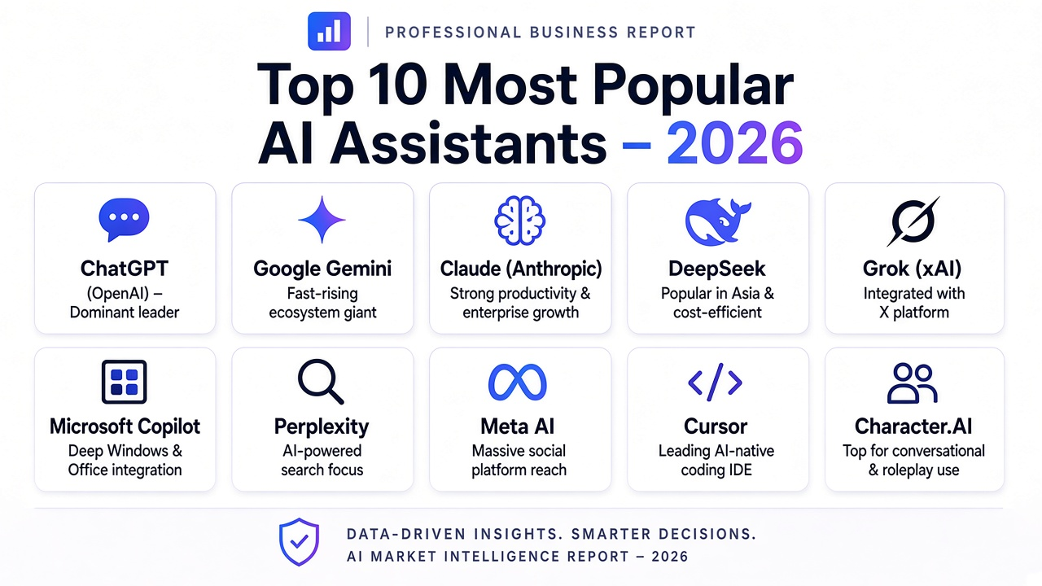

Microsoft Power Automate
The primary low-code workflow automation product, Microsoft Power Automate, was examined. Creating workflows that could link various programs and carry out a series of predetermined activities automatically was the practical effort.
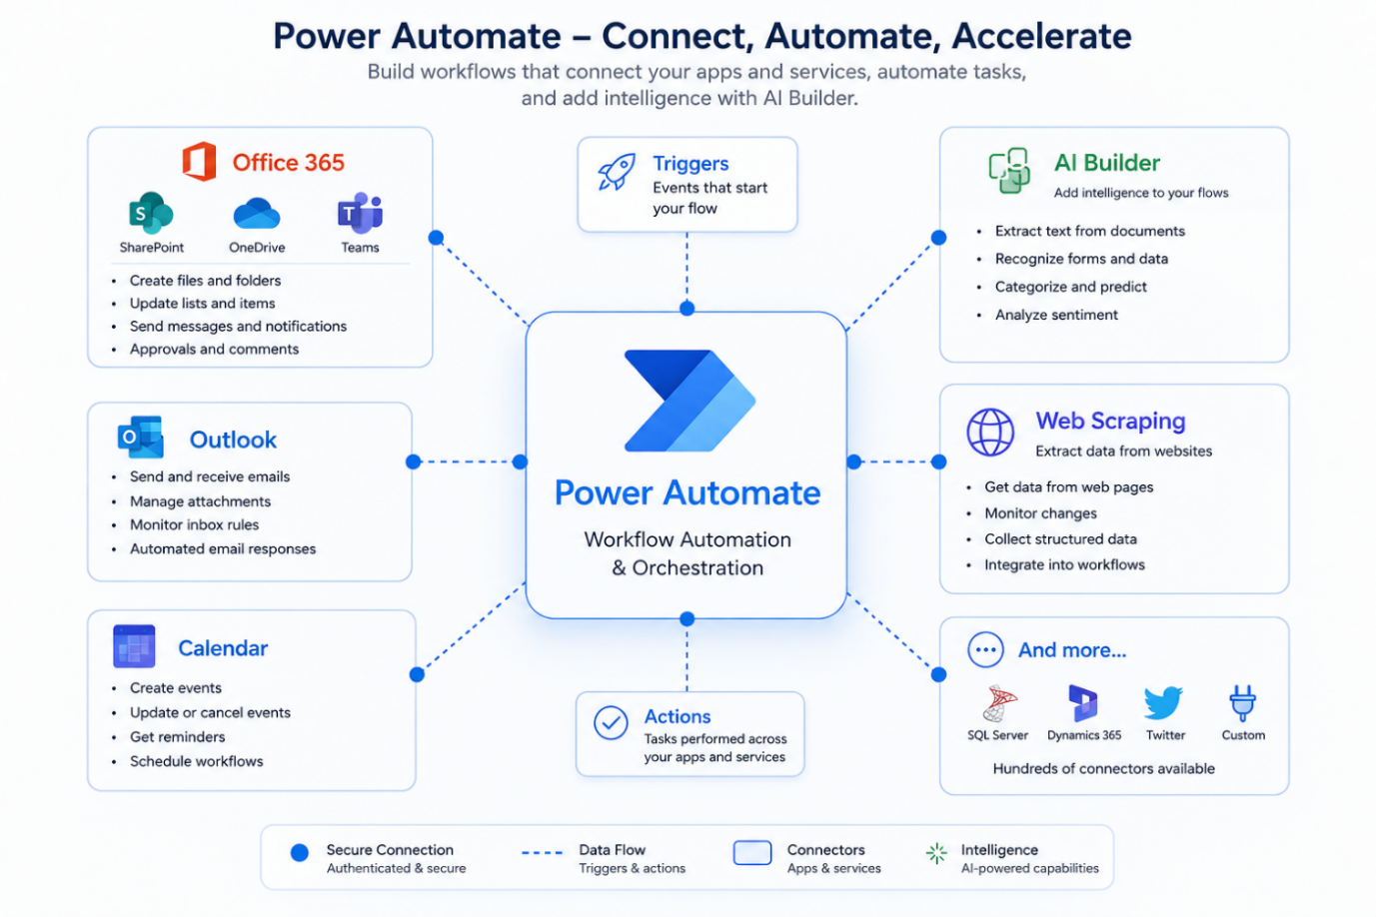Working with Outlook emails, attachments, files, folders, and various workflow tasks were all part of the inquiry. Processes where information arrives by email and needs additional processing received special attention. Workflows were created to identify incoming data, retrieve attachments, store files, and transfer data to further phases of the procedure.
This practical experiment demonstrates how Power Automate may considerably minimise the amount of code needed to construct efficient business operations. However, understanding triggers, actions, conditions, variables, expressions, connectors, and error handling is still required for constructing dependable workflows.
A low-code system allows for flexible workflow customization, taking into account all the specifics, but it requires a more in-depth understanding of the subject matter. In addition to knowing how to use these tools, you may also need some basic programming knowledge to fine-tune the condition-state relationships. However, even learning the standard tools is enough to create a powerful workflow.
The most basic and useful scenarios might look like this:
- Web data extraction
Power Automate Desktop can extract data from websites, including spreadsheets, web pages, and internal corporate systems. This is especially handy when a worker needs to visit the website on a frequent basis and manually collect data.
- Automated invoice retrieval and storage.
For example, Flow can detect a new invoice on a website, download the PDF, and save it to a specified folder or SharePoint/OneDrive. The document can then be renamed using a predetermined template and saved in a spreadsheet or accounting system.
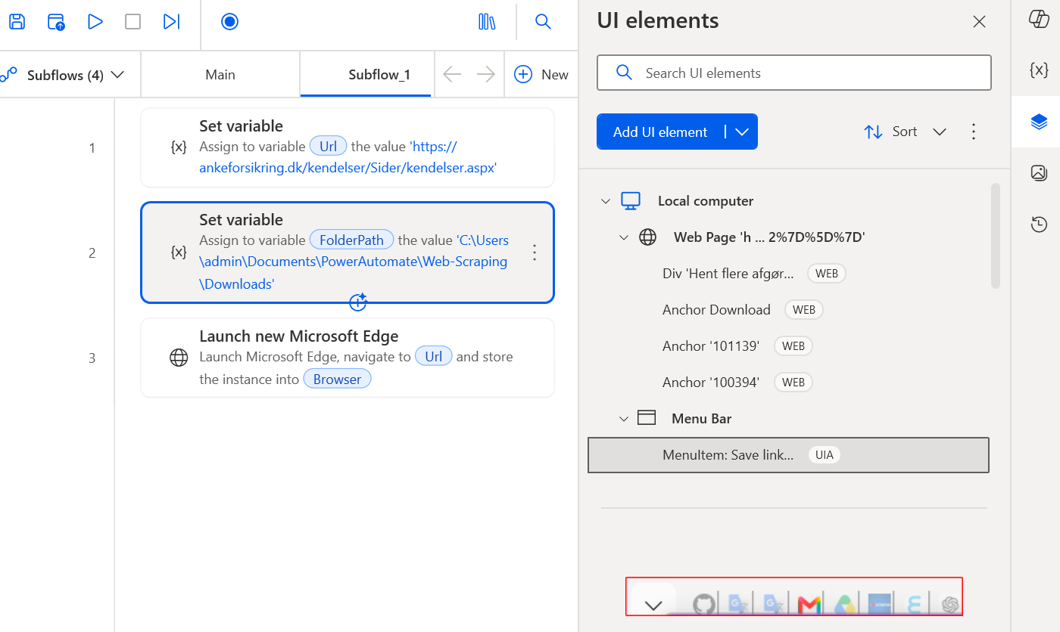
- Text recognition
Processing PDFs and pictures with pluggable OCR or AI Builder
- Automatic creation of statements, reports.
Collected data can be utilised to generate statements, registers, and summary reports automatically. For example, Power Automate may collect invoice data for a specified time period, process it, and output an Excel file containing amounts, dates, vendors, and statuses.
- Event-triggered automation
Flow can be launched automatically when a certain event occurs. Examples include creating new files, receiving emails, changing records in SharePoint/Dataverse, receiving forms, and creating invoices.
This enables to transition from a manual program launch to an event-based automation strategy.
- Scheduled automation
Another alternative is to run processes on a set timetable. For example, every day at 6:00 p.m., the system can scan the site for new invoices, download them, and update the register. Similarly, weekly and monthly reports can be created.
- Interaction between Power Automate Cloud and Desktop
Cloud flows can handle orchestration, such as receiving emails, recognising the arrival of a new document, and initiating a Desktop flow. Power Automate Desktop, in turn, may interface with websites and local Windows applications, as well as local files and databases like MS SQL Server.
Separating processes into cloud and desktop is very useful, as many companies have sensitive data and are concerned about storing it in the cloud. Separating these processes allows for a flexible approach to segregating sensitive information.

Microsoft Copilot
Copilot is a sophisticated tool that is extremely useful when combined with numerous Microsoft apps. However, it cannot record automatic interactions between products.
This AI tool was tested as an AI-powered assistant in the Power Automate environment. The purpose was to see how natural language interaction could help with the design and understanding of automated procedures.
Copilot was used to explain the necessary processes and make ideas for workflow architecture and actions. It was excellent for brainstorming ideas, outlining available activities, and identifying how a given process could be organised.
However, the analysis discovered a major flaw. While Copilot could provide recommendations and assist with workflow logic, it did not generate a fully configured, minimally coded workflow without user participation. Individual workflow components have to be selected, configured, connected, and tested. As a result, Copilot served as a beneficial workflow development assistance rather than a fully autonomous workflow developer.

AI Builder
A method for integrating artificial intelligence capabilities into Power Automate operations was investigated: AI Builder. Text and document processing—more especially, the extraction of useful information from papers—was the main focus.
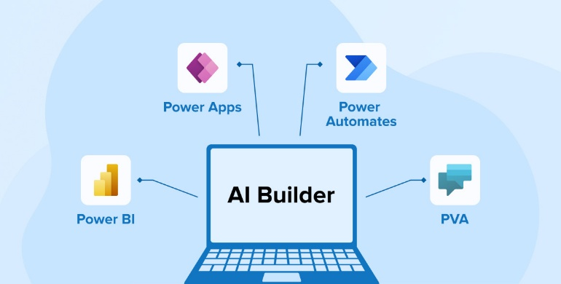
The practical study entailed looking into how documents could be handled automatically and how information detected by AI Builder could be routed to the next stages of a workflow. This highlighted an essential distinction between traditional workflow automation and AI-assisted automation. A standard workflow normally works with structured data and predefined rules, but AI Builder can assist the process in interpreting information included in documents.
The investigation also showed that the accuracy of the data collected can be impacted by the original document's quality and structure. Because of this, AI Builder can remove the need for manual data entry; but, if the information is crucial or the original document is poorly written, the outputs could still need to be verified.

Claude AI
Claude was researched as a general-purpose AI helper with more capabilities than the specific AI functions present in Power Automate. The practical examination focused on its ability to assess information, interact with unstructured content, explain things, develop content, and help with more sophisticated activities.
Claude's capacity to work with information saved in cloud-based systems, as well as its connectivity with platforms like Notion, were highlighted. This demonstrated the feasibility of deploying Claude as a higher-level AI assistant capable of working with data acquired and structured by other automated procedures.
Simultaneously, the investigation revealed a crucial problem concerning confidential company data. Sensitive client, project, contractual, and financial data that shouldn't be shared with outside cloud-based AI services may be handled by construction companies. Because of this, even tho Claude offers helpful support, its use in a real-world business context needs to be tempered with concerns about data security, privacy, and storage.
Claude has a very interesting concept using MCP (Model Context Protocol). Claude developed this protocol, which allows for the creation of various connectors and integration with a huge number of third-party applications, which offers Claude tremendous potential. This protocol is currently used by many AI systems and has already become a standard for integration. It's an open-source technology and is supported by many major software vendors, including Microsoft, Google, JetBrains, and others. Claude has a wide variety of connectors, which are sufficient for solving everyday routine tasks, but it's also possible to create custom connectors for specific office applications, which adds flexibility and offers great potential for AI assistants.
The free edition of Claude has a lot of features, so it's a wonderful place to practise and learn. However, you'll probably need to subscribe to a paid plan in order to fully utilise this AI, which is a big deal for a tiny construction company.
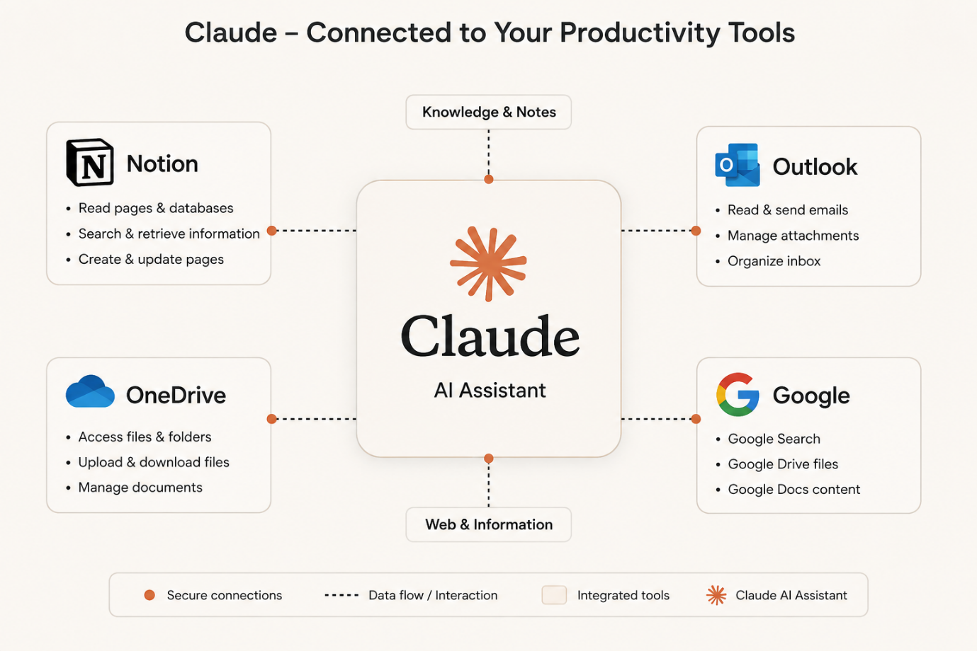
One of Claude's unique capabilities, as mentioned earlier, is its tight integration with the popular and flexible Notion database via the MCP connector. This allows users to quickly create centralized data stores in the Notion cloud, making them accessible to all employees. However, there's a catch: many companies have sensitive and confidential data that they prefer to store locally to prevent leaks. Notion has a disadvantage in this regard, as everything is stored in the cloud, which limits its use.
Another distinctive feature of Claude is the ability to create Skills, whether your own or pre-made ones. Loading and selecting a specific skill tells Claude what we want him to do, and he then acts on that, applying his best abilities.
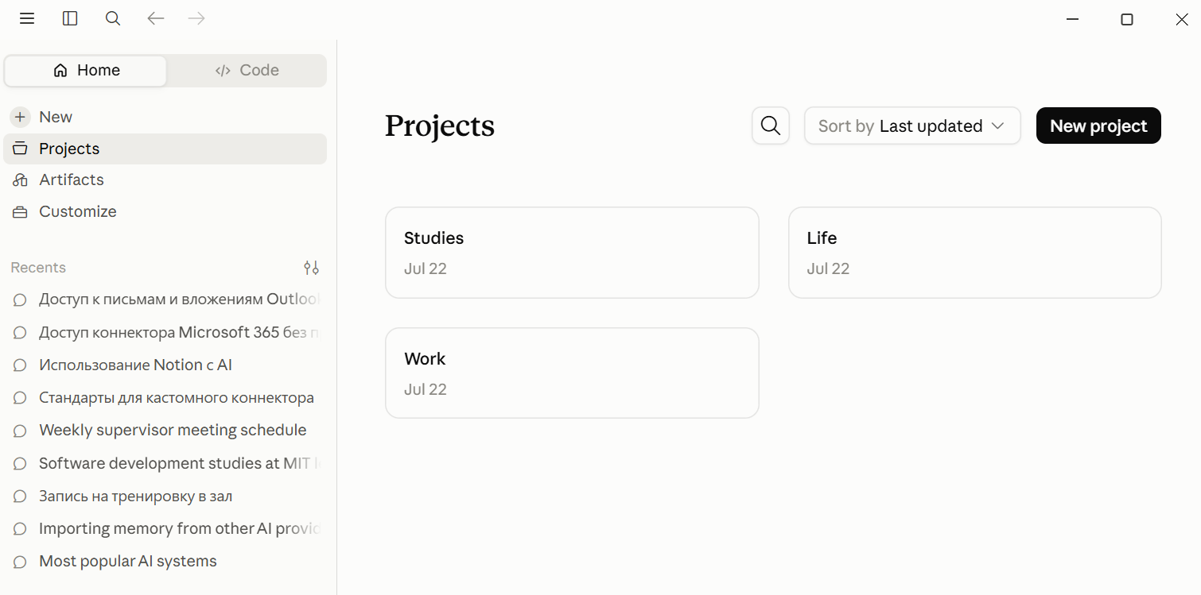
Additionally, Claude allows you to create Projects. Within a Project, we can use specific skills, and Claude will learn to do specific things related to a specific task. In our case, in a Project, we can create a specific ability, train Claude, set up scheduled tasks, and thus Claude will become a mini-helper who will perform routine tasks and constantly learn, making his skills more valuable.
This research also showed that among the many AIs, each has its own unique characteristic: some are better at answering everyday questions, others are better at drawing, and still others are better at handling workflows. But none yet offers universal versatility across all tasks. For example, Claude is terrible at drawing diagrams, unlike ChatGPT, while another AI, Cursor, works excellent as an AI coding assistant for programmers.
The practical examination revealed that the four technologies have varied applications and can compliment one another. Power Automate provides the low-code workflow and automation layer, AI Builder adds specialist AI capabilities to the workflow, and Copilot aids in the design and comprehension of Power Automate processes. Claude offers broader AI support for jobs that need information processing, reasoning, and unstructured content.
This shows that selecting one technology as a complete solution is not always the most effective option. Instead, different technologies might be assigned to jobs that best suit their capabilities. This is the foundation for the suggested notion of specialist AI mini-assistants, in which monotonous tasks can be allocated to individual automated or AI-assisted procedures while managers maintain control over critical decisions.

Results
Numerous technologies that may be utilised to enable AI-assisted construction workplace management were found in the study. These include cloud services, general-purpose AI assistants, workflow automation platforms, AI-based document processing tools, and other AI technologies. According to the inquiry, many of these technologies have strong potential, but before they can be used successfully in a small organization, some of them need more complicated configuration and somewhat advanced technical skills.
As a result, the study found several technologies that offer a more approachable method. Specifically, Microsoft Power Automate, AI Builder, and Claude showed practical features that can be used without creating an entire AI system from scratch. While AI Builder can include document recognition and information extraction features, Power Automate offers a reasonably accessible low-code environment for creating workflows. Claude offers more comprehensive AI support for information analysis, handling unstructured content, and helping people with activities requiring interpretation and reasoning.
The results of the investigation showed how promising the selected technologies were for helping with repetitive duties at work. However, the results also demonstrated that no single technology provides all the features required for a complete AI-assisted workplace solution. Each tool has its benefits and drawbacks. This suggests that it would be more practical to use a range of complementary technologies rather than a single platform.
The use of Microsoft Copilot in Power Automate was one significant discovery. According to the study, Copilot can help the user by recommending workflow architecture, actions, expressions, and potential automation strategies. But unlike what a developer may anticipate from a fully autonomous AI system, it does not autonomously create entire low-code Power Automate routines. It is still necessary for the user to comprehend the Power Automate environment, choose and set up activities, link services, and confirm the final workflow. This shows a disconnect between fully autonomous low-code workflow development and the capabilities of a generic AI assistant.
Claude's inquiry yielded conflicting findings. Claude showed a great deal of promise for handling data kept in cloud-based contexts, as well as practical integration skills with platforms like Notion. Because of this, it could be useful as an AI assistant for retrieving, sorting, and interpreting workplace data. However, there are issues with using cloud-based AI services when private or sensitive enterprise data is involved. Documents for a construction company could include client data, contracts, financial information, project specifics, or other information that the company would wish to preserve inside its own infrastructure.
This led to a crucial practical concern for the suggested solution: an AI tool's suitability for a business depends on more than just its technological skills. Organisational policies, storage location, data security, privacy, and client needs must all be taken into account. The suitability of solutions that require sensitive data to be transferred to external cloud-based AI services is limited in the investigated scenario due to the requirement that confidential information remain locally stored.
The discovery of a possible use for specialised AI mini-assistants was another outcome of the study. Routine duties might be split among multiple specialised assistants rather than relying on a single AI system to handle every task at work. Workflow automation can regulate when and how a task is completed, while each helper can concentrate on a specific task. This strategy might enable a small business to progressively implement AI support without needing a massive enterprise-level system or altering its current procedures.
All things considered, the study shows that AI-assisted automation has a lot of real-world potential for small construction firms, especially when managers are in charge of a lot of repetitive administrative tasks. The analysis also showed that a combination of technology, suitable human control, and careful consideration of data security are necessary for successful implementation. The findings thus indicate a hybrid strategy where sensitive data is kept under proper organisational control while automation, specialised AI tools, and general-purpose AI helpers complement one another.

Conclusion
This research looked into how workplace management in a small construction company with one or two managers may be supported by workflow automation and artificial intelligence. The study concentrated on useful and approachable technology that may lessen tedious administrative tasks and free up managers' and directors' time for tasks requiring expert judgement and decision-making.
The study showed that a variety of automation and artificial intelligence technologies are available for this use. But there are significant differences in their applicability. Certain technologies offer sophisticated features but necessitate extensive technical expertise, setup, or auxiliary equipment. AI-assisted processes can be introduced into small organisations more easily with the help of other tools like Microsoft Power Automate, AI Builder, and Claude.
The results also showed that these technologies don't always have to be seen as rivals. Their skills compliment each other. AI Builder can add specific AI-based document processing and information extraction, Power Automate can supply the workflow and automation structure, and Claude can offer more general help with information analysis, reasoning, and working with unstructured content. Therefore, combining these features can offer a more adaptable solution than depending just on one technology.
However, the study also found a number of significant shortcomings. Information produced and extracted by AI is not always entirely trustworthy and may need to be verified by a human. Copilot's capacity to autonomously create whole Power Automate workflows was also shown to have limitations. Furthermore, there are significant concerns about sensitive and private company data when using cloud-based AI services like Claude. Before using such technologies in an actual corporate setting, these aspects need to be taken into account.
One possible direction for future development is the idea of specialised AI mini-assistants. Individual assistants could be allocated to particular repetitive duties and connected thru automated processes rather than trying to construct a single sophisticated system that oversees every business process. With this strategy, a small construction company may progressively implement AI and reap its benefits without needing the infrastructure, specialised personnel, or funding often associated with huge enterprise systems.
Overall, the study comes to the conclusion that AI-assisted automation has significant potential to serve small construction companies, especially in lowering administrative and repetitive information processing tasks. But rather than taking the position of human managers entirely, AI should be viewed as a helper. Combining automation, specific AI skills, general-purpose AI support, and human supervision is probably the most realistic strategy. With this strategy, managers and directors can assign regular work to AI-assisted processes while still being in charge of making decisions that call for judgement, expertise, and a grasp of the business environment.

References
Adebayo, Y., Udoh, P., Kamudyariwa, X. B., & Osobajo, O. A. (2025). Artificial intelligence in construction project management: A structured literature review of its evolution in application and future trends. Digital, 5(3), 26.
Anders Jensen. (2025, June 18). Download PDFs in Bulk with Power Automate Desktop (Web + UI Automation) [Video]. YouTube. https://www.youtube.com/watch?v=-IXu7Rg3Wcc
Cattermole, A. (2026). Chatting with AI: Exploring the Influence of Coworker Support Type and Alignment on Applied AI Chatbot Use at Work (Doctoral dissertation, University of Canterbury).
CeleneA. (n.d.). Exercise - Create recurring flows - Training. Microsoft Learn. https://learn.microsoft.com/en-gb/training/modules/get-started-flows/6-flow-scheduled-flows
Darrel Wilson. (2026, April 10). Claude Tutorial for beginners — How to use Claude AI step by step (2026) [Video]. YouTube. https://www.youtube.com/watch?v=-xEF5WrdIWs
Eber, W. (2020). Potentials of artificial intelligence in construction management. Organization, technology & management in construction: an international journal, 12(1), 2053-2063.
Habib, H. (2024). OpenAI API Cookbook: Build intelligent applications including chatbots, virtual assistants, and content generators. Packt Publishing Ltd.
Hayawi, K., & Shahriar, S. (2024). AI agents from copilots to coworkers: Historical context, challenges, limitations, implications, and practical guidelines.
Ivanova, S., Kuznetsov, A., Zverev, R., & Rada, A. (2023). Artificial intelligence methods for the construction and management of buildings. Sensors, 23(21), 8740.
Kaisar Kurmangaliyev. (2026, June 22). COMPLETE COURSE on Claudio for 2026 (from beginner to pro) [Video]. YouTube. https://www.youtube.com/watch?v=r3KVQQ90Au4
Kevin Stratvert. (2021b, November 17). Microsoft AI Builder Tutorial - Extract Data from PDF [Video]. YouTube. https://www.youtube.com/watch?v=J3d6bx3i4l0
Kevin Stratvert. (2026, April 30). Claude AI Tutorial for Beginners (Step-by-Step) [Video]. YouTube. https://www.youtube.com/watch?v=r2vYObllqJU
Kevin Stratvert. (2021, November 17). Microsoft AI Builder Tutorial - Extract Data from PDF [Video]. YouTube. https://www.youtube.com/watch?v=J3d6bx3i4l0
Koduri, N. K., & Piridi, S. Low-Code AI-Driven Patient Intake System Using Microsoft Power Platform and AI Builder.
Leila Gharani. (2021, March 18). Streamline Excel: Power Automate tricks you need to know! [Video]. YouTube. https://www.youtube.com/watch?v=YBi9PgbnfLQ
Pothireddy, S. R. (2025). AI-Powered Copilots Are Revolutionizing Low-Code Development in the Power Platform. International Journal of Communication Networks and Information Security, 17(2), 86-115
Pragmatic Works. (2021, December 9). Power Automate Beginner to Pro Tutorial [Full Course] [Video]. YouTube. https://www.youtube.com/watch?v=1p5kI7SYz4Q
Savaş, S. (2025). Artificial intelligence in construction project management: Trends, challenges and future directions. Journal of Design for Resilience in Architecture and Planning, 6(2), 221–238. https://doi.org/10.47818/DRArch.2025.v6i2165
Stratton, J. (2024). Copilot for Microsoft 365: Harness the power of generative AI in the Microsoft apps you use every day. Apress.
Thomas Janssen. (2026, January 3). Power Automate Excel Tutorial: Add, Update and Read from Excel [Video]. YouTube. https://www.youtube.com/watch?v=M7gaUl4MsZ4
Zabala-Vargas, S., Jaimes-Quintanilla, M., & Jimenez-Barrera, M. H. (2023). Big data, data science, and artificial intelligence for project management in the architecture, engineering, and construction industry: a systematic review. Buildings, 13(12), 2944.

